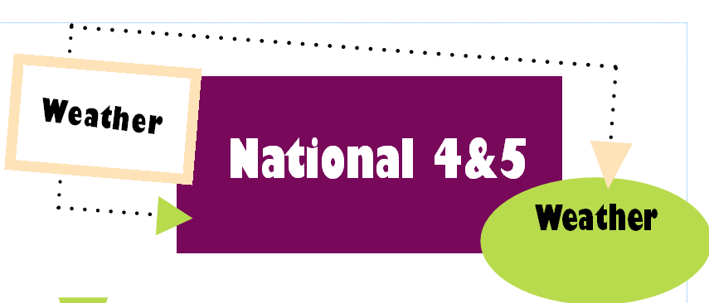
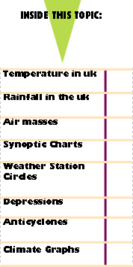
You should be able to answer questions that ask you to:

- Predict the weather from a synoptic chart.

- Explain why an area is experiencing certain types of weather.

- Describe the weather conditions we might expect if a country is further North, at a greater altitude etc.
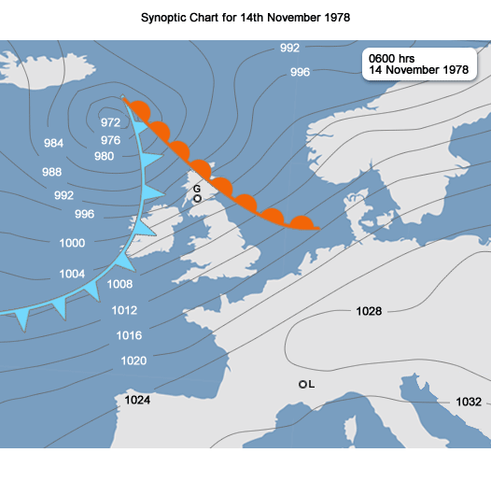
Anticyclone
Depression

Temperature of the UK
Distance from the Sea: Warm water from the Atlantic Ocean loses warmth slower than land. This keeps the coastal areas warmer than areas inland.

The temperature varies around the UK. Explain why we have different temperatures with reference to altitude, latitude and the distance from the sea.
6 Marks

Latitude:

1. The further away from the equator the cooler it is.

2. The sun is more concentrated at the equator making it warmer, in the north the sun’s rays have to heat a larger area making the overall temperature cooler.

3. The atmosphere is thicker in the North, meaning more of the suns energy is lost, making the temperature colder.

Altitude: The higher up you go the colder it is. For every 100m in height gained the temperature goes down 1 degree.

Rainfall in the UK –Altitude
Upland areas in the UK receive more rain than lowland areas.
This is because:
•Moist air (containing lots of water vapour) blows from the Atlantic Ocean and reaches hills in the SW.
•The air rises over the hills and cools down.
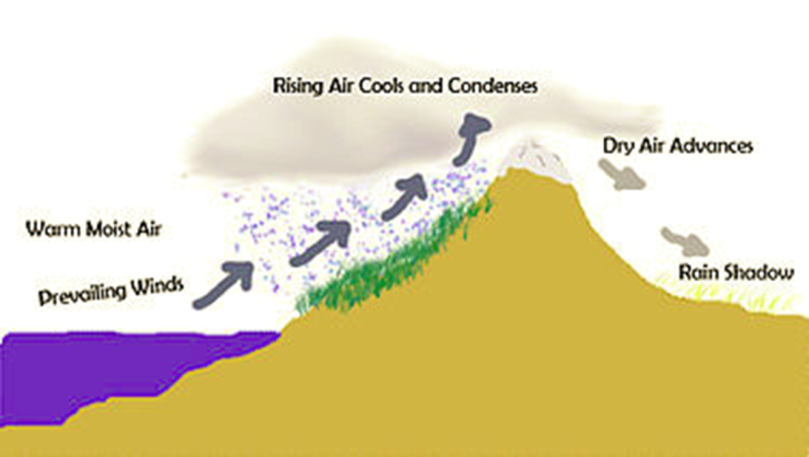
•As it cools down the water vapour condenses into liquid droplets.
•Clouds form as millions of droplets condense.
•The water droplets become bigger and fall as rain.

Rainfall in the UK—Aspect/ Direction

The hillsides which face the moist winds receive the most rain.
In the UK these are the west facing slopes because the Atlantic Ocean in to the west.
On the other side of the hill there is less rainfall. This is known as a rain shadow.

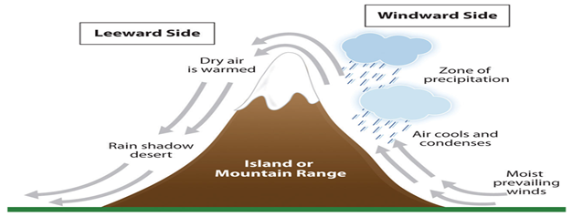

Rainfall in the UK—Distance from the Sea

Most of our rain is collected over the Atlantic Ocean. This is why we get more rain on the West coast than on the East coast.

Anticyclones

- experienced less often in UK but can remain for several days
- air descends and pressure increases
- winds light and in clockwise direction
- may be periods of calm
- air descends and warms

settled conditions
clear skies
lack of rain

Summer Winter

* Little or no cloud * Low daytime temps
* Warm and sunny in day * Dry and bright
* At night temperatures drop quickly * Cold nights
* Air at ground level will cool and * Condensation at ground level
condense giving dew and mist Gives frosts and fogs
* Risk of thunderstorms (convectional
rain) under heat-wave conditions

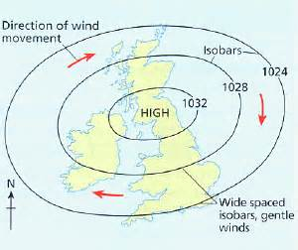

THE PASSAGE OF A DEPRESSION

1. Warm front approaches (air rises) clouds begin to form.

2. Clouds get lower and thicker.

3. Winds blow from SE in anticlockwise direction and slowly increase in strength.

4. Air rises, atmospheric pressure drops (less weight on the earth).
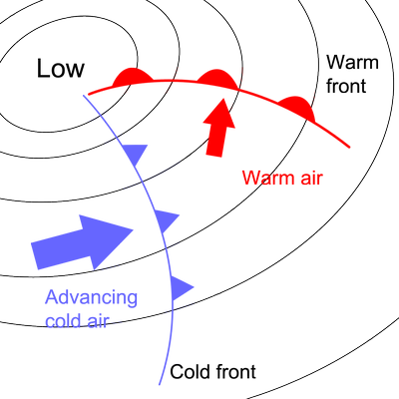
5. Warm front passing usually characterised by:
A lengthy period of steady rain
Low cloud
Strong winds

6. Warm front passes and there’s a sudden:
Temperature rise
Winds turn to S-Westerly

7. Warm sector passes over with:

Low, broken cloud
Decreasing winds
Drizzle or dry weather

8. As cold front passes weather deteriorates quickly.
Winds often at gale force from N-West
Heavy rainfall (short duration)
Temperature falls rapidly

9. After cold front passes, pressure increases and weather slowly improves.

10. Heavy showers instead of rain followed by:
Sunny intervals
Winds are cold and become moderate (still from N.West)

* A depression will take between 1 and 3 days to pass over the UK.

Weather Station Circles and Synoptic Charts

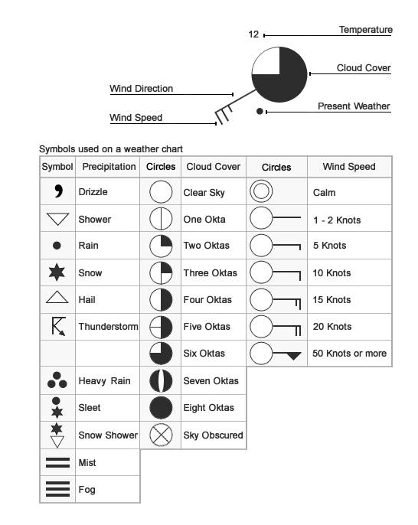
Isobars:
- The closer together the stronger the wind
- If they are close it is a low pressure system, Depression.
- If they are far apart there is little wind.
- If they are far apart it is a high pressure system, Anticyclone.

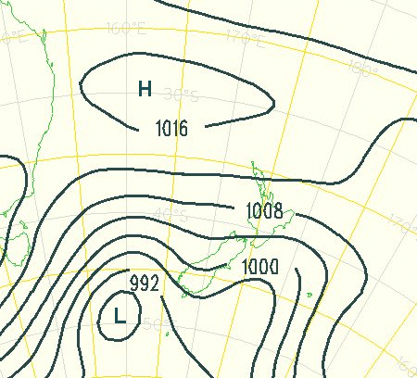

Air Masses Blow wind blow
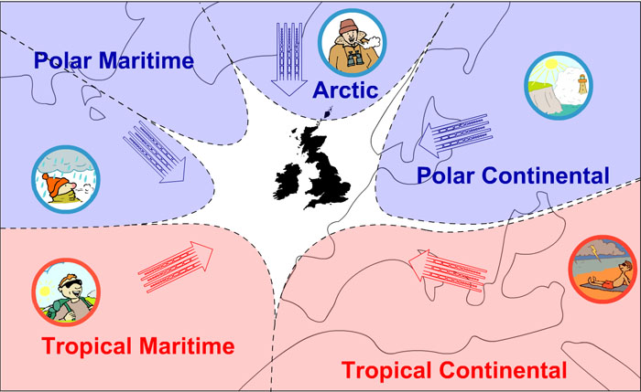
Climate Graphs

Describing temperature
Is the temperature the same all year round?
Which season is the warmest?
Is this warm (10 - 20° C), hot (20- 30° C) or very hot (30° C)?
Which season is the coolest?
Is this mild (0 - 10° C), cold (-10 - 0° C) or very cold (below -10° C)?
What is the range of temperature? (Subtract the minimum temperature from the maximum temperature)
Write down the temperature and state if it is warm, hot etc.

Describing Rainfall
Does rainfall occur all year round?
What is the pattern of the rainfall (i.e. which season(s) is/are drier or wetter than others)?
Is the rainfall high, moderate or low?
What is the total annual rainfall? (Add each month's total together)

